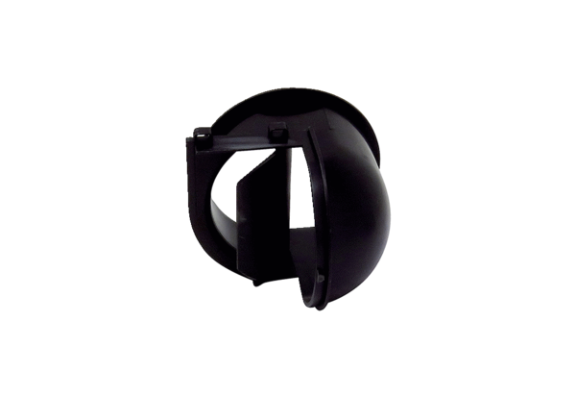Air outlet element AEH ER ECRange: B
Article number: E059.2054.0000Manufacturer: MAICO

