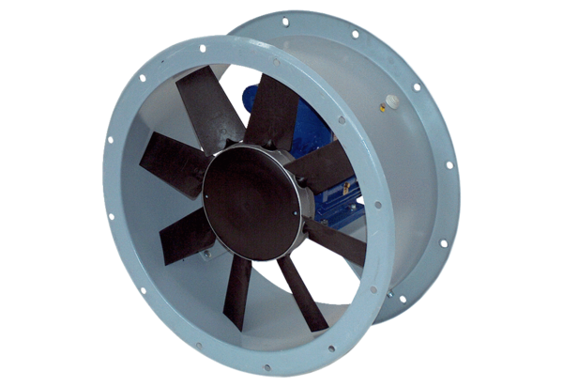Axial duct fan DAR 80/6 1,5Packing unit: 1 pieceRange: C
Article number: 0073.0147Manufacturer: MAICO

