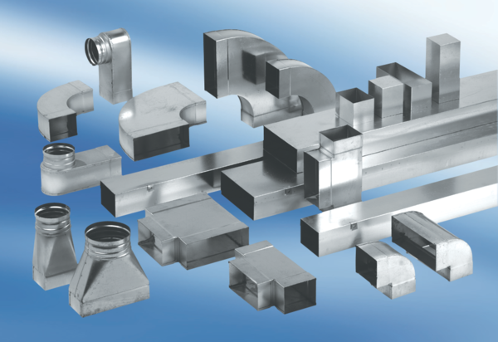45° channel elbows, horizontal KB45H/70/170Packing unit: 1 pieceRange: K
Article number: 0055.0584Manufacturer: MAICO

