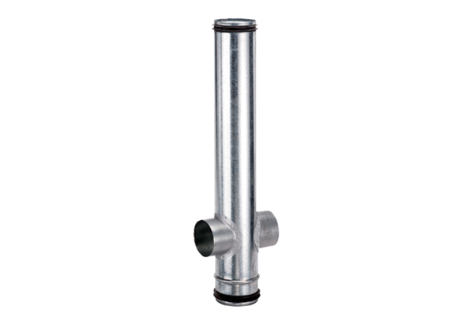Fire protection compensation element BA 125/80-2Packing unit: 1 pieceRange: B
Article number: 0093.1005Manufacturer: MAICO

