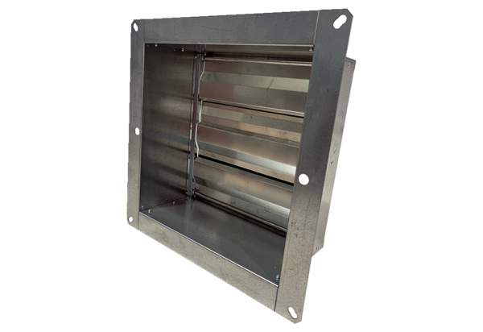Channel shutter VKRI HV 40-45Packing unit: 1 pieceRange: C
Article number: 0073.0557Manufacturer: MAICO

