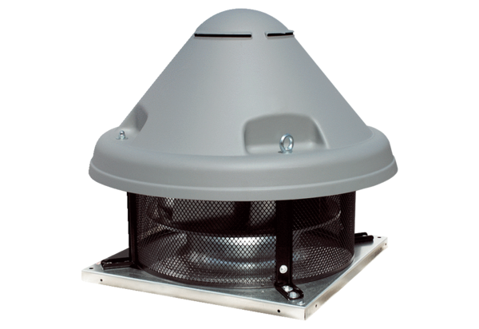Centrifugal roof fan DRD H 90/6 ExPacking unit: 1 pieceRange: C
Article number: 0073.0544Manufacturer: MAICO

