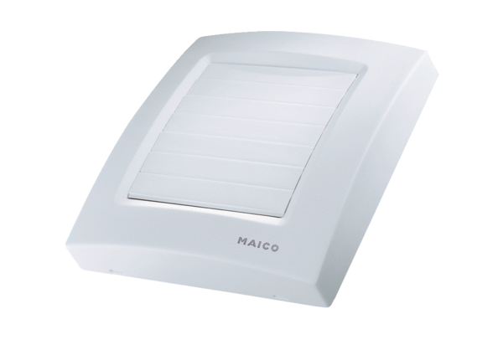Cover ABDK ECA 150 1Range: A
Article number: E059.1025.9000Manufacturer: MAICO

