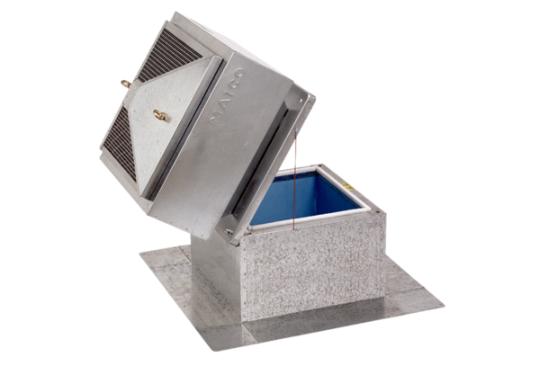Roof socket for flat roofs, tiltable SOK 35Packing unit: 1 pieceRange: C
Article number: 0093.0994Manufacturer: MAICO

