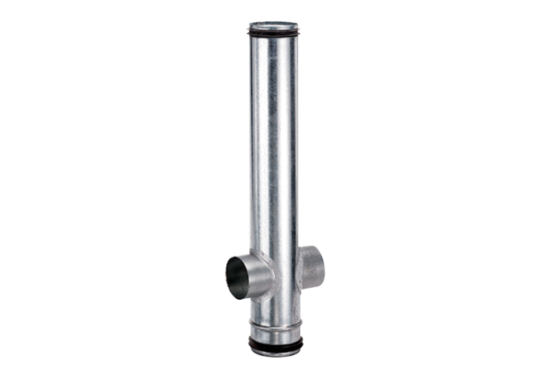Fire protection compensation element BA 200/80-2Packing unit: 1 pieceRange: B
Article number: 0093.1007Manufacturer: MAICO

