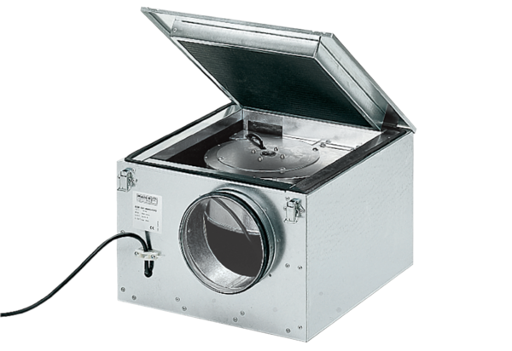Sound-insulated ventilation box ESR 31/1Packing unit: 1 pieceRange: C
Article number: 0080.0285Manufacturer: MAICO

