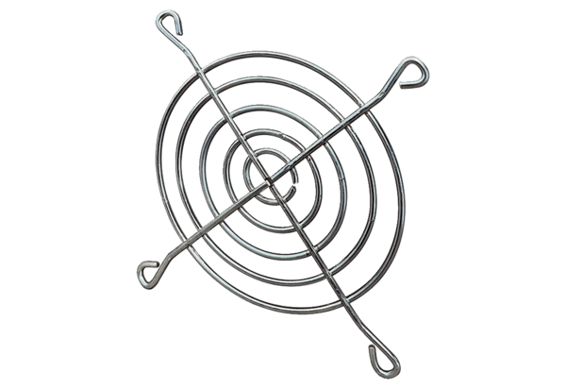Air outlet grille SGAI 12Packing unit: 1 pieceRange: C
Article number: 0073.0289Manufacturer: MAICO

