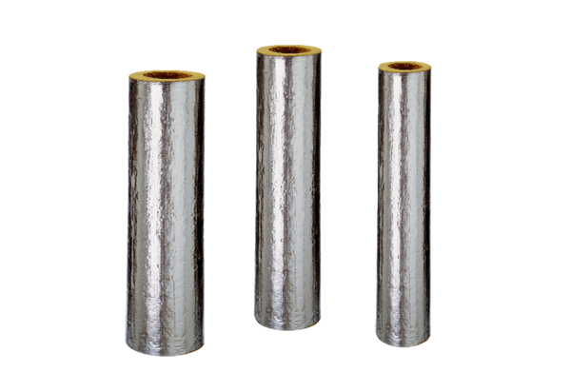Fire protection insulation BI 125Range: B
Article number: 0092.0396Manufacturer: MAICO

