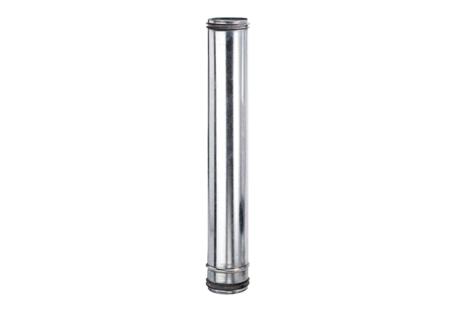Fire protection compensation element BA 125-0Packing unit: 1 pieceRange: B
Article number: 0093.1020Manufacturer: MAICO

