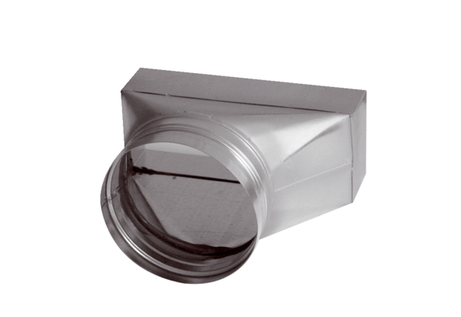Intermediate piece, asymmetric USAN80/100/80Packing unit: 1 pieceRange: K
Article number: 0055.0665Manufacturer: MAICO

