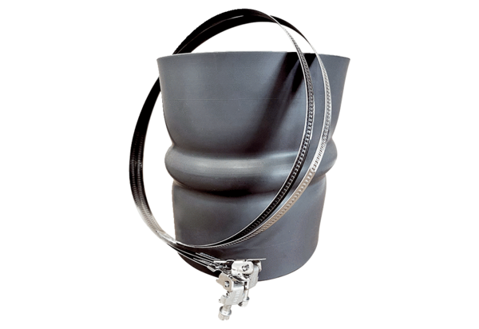Flexible cuff STKI 50Packing unit: 1 pieceRange: C
Article number: 0073.0495Manufacturer: MAICO

