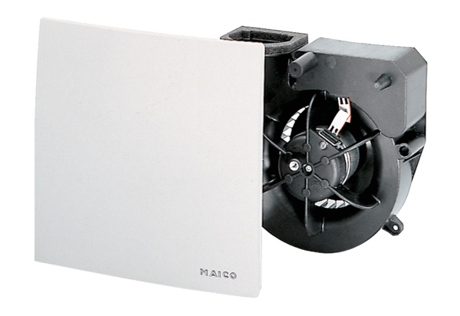Fan insert ER 60 VZ 15Packing unit: 1 pieceRange: B
Article number: 0084.0108Manufacturer: MAICO

