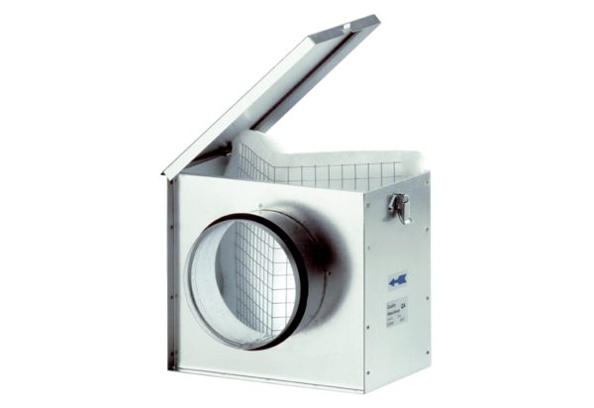Air filter TFE 25Packing unit: 1 pieceRange: C
Article number: 0149.0044Manufacturer: MAICO

