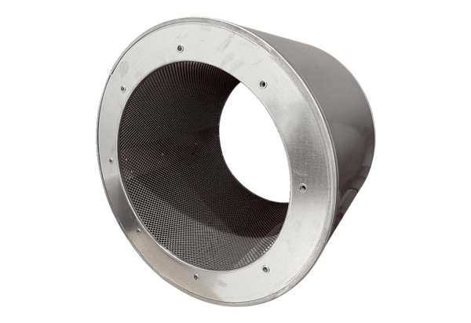Tubular sound absorber RSI 112/2000Packing unit: 1 pieceRange: C
Article number: 0073.0246Manufacturer: MAICO

