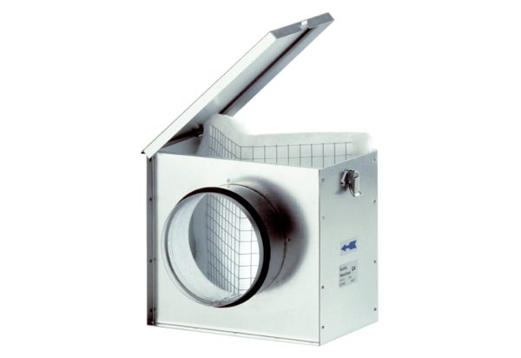Air filter TFE 31Packing unit: 1 pieceRange: C
Article number: 0149.0045Manufacturer: MAICO

