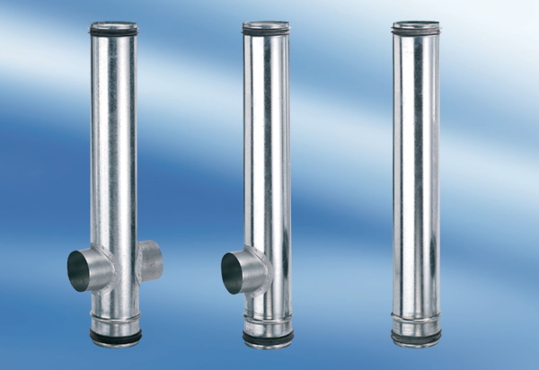BA 200/100-2Packing unit: 1 pieceRange: B
Article number: 0093.0055Manufacturer: MAICO

