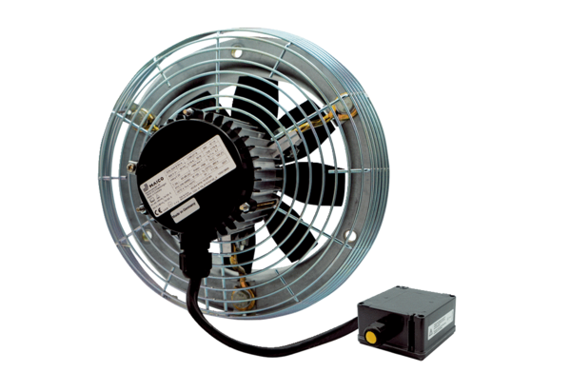Axial wall fan DZS 50/4 B Ex tPacking unit: 1 pieceRange: C
Article number: 0094.0214Manufacturer: MAICO

