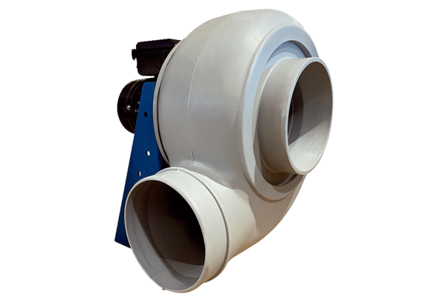Centrifugal blower GRK R 63/4 DPacking unit: 1 pieceRange: C
Article number: 0073.0532Manufacturer: MAICO

