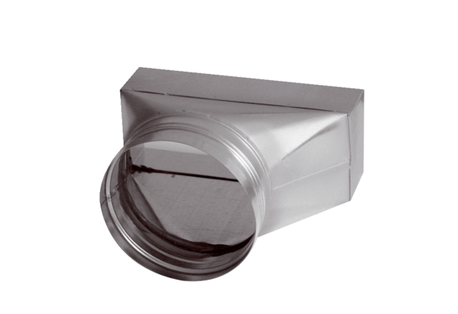Intermediate piece, asymmetric USAN55/220/80Packing unit: 1 pieceRange: K
Article number: 0055.0659Manufacturer: MAICO

