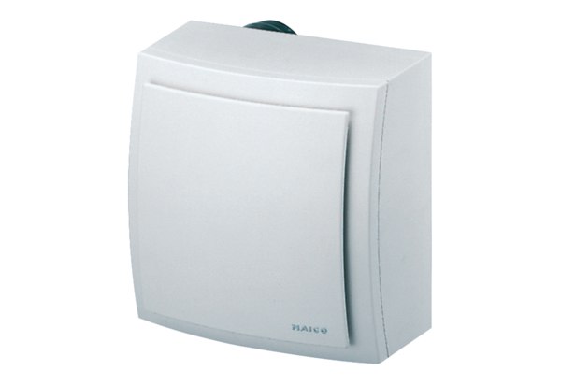Surface-mounted fan, fire protection ER-APB 60 FPacking unit: 1 pieceRange: B
Article number: 0084.0158Manufacturer: MAICO

