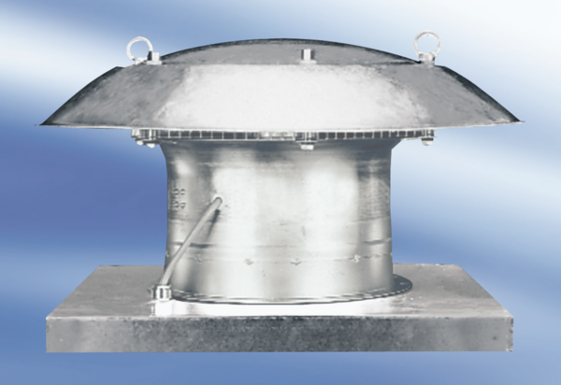Axial roof fan EZD30-4APacking unit: 1 pieceRange:
Article number: 0087.0404Manufacturer: MAICO

