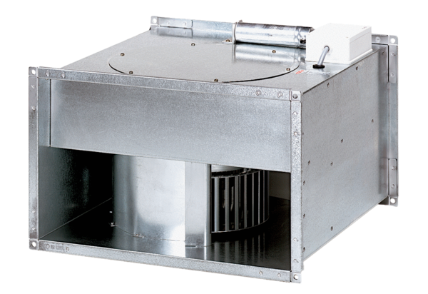Channel fan DPK 31/4 BPacking unit: 1 pieceRange: D
Article number: 0086.0667Manufacturer: MAICO

