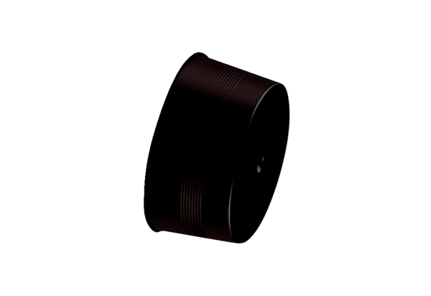Sealing cover MA-VD75Packing unit: 10 piecesRange: K
Article number: 0059.2138Manufacturer: MAICO

