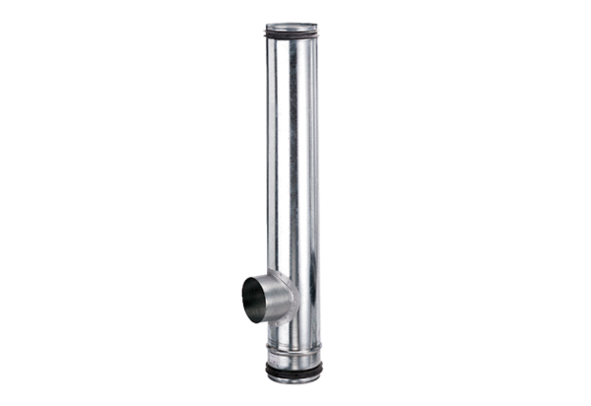Fire protection compensation element BA 125/80-1Packing unit: 1 pieceRange: B
Article number: 0093.1001Manufacturer: MAICO

