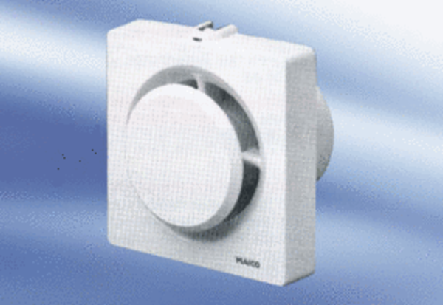Small room fan ECA 11-1 KFPacking unit: 1 pieceRange:
Article number: 0080.0505Manufacturer: MAICO

