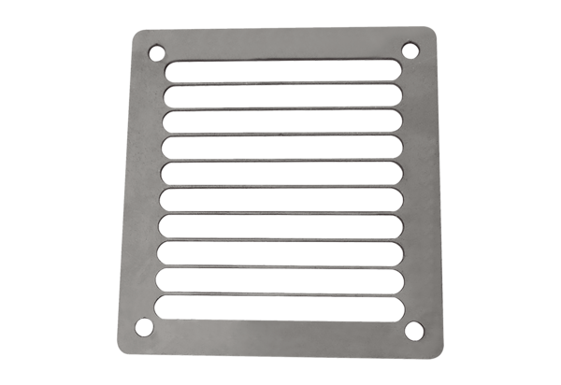Air outlet grille SGAI ES 12Packing unit: 1 pieceRange: C
Article number: 0073.0326Manufacturer: MAICO

