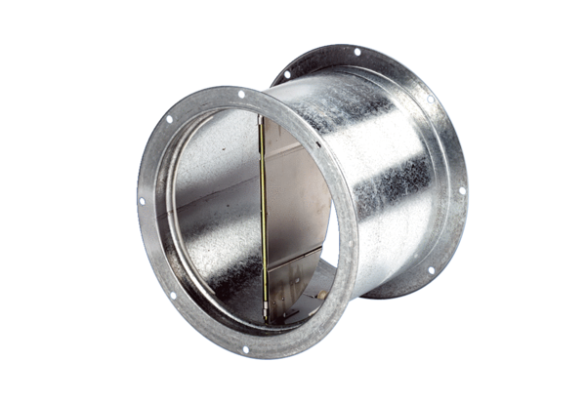Shutter, pull device VD 50Packing unit: 1 pieceRange: C
Article number: 0093.0106Manufacturer: MAICO

