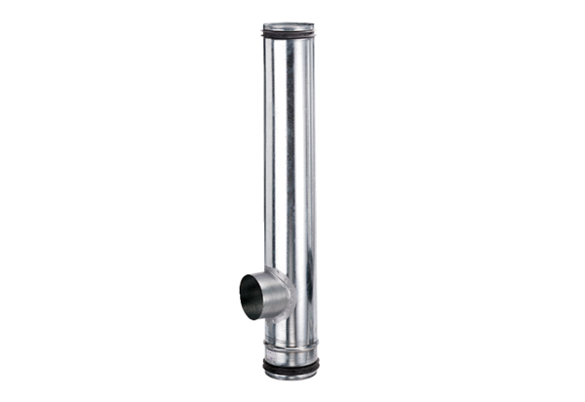Fire protection compensation element BA 100/80-1Packing unit: 1 pieceRange: B
Article number: 0093.1000Manufacturer: MAICO

