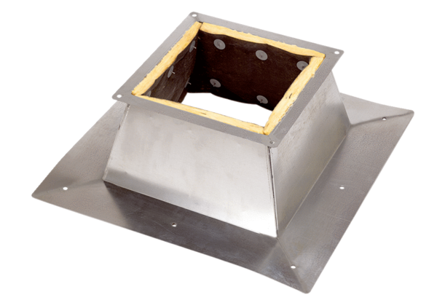Roof socket for flat roofs SO 40Packing unit: 1 pieceRange: C
Article number: 0093.0363Manufacturer: MAICO

