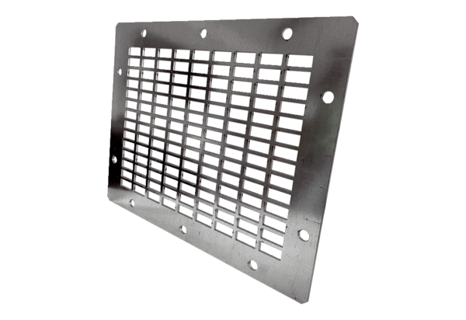Air outlet grille SGAI GR 28Packing unit: 1 pieceRange: C
Article number: 0073.0428Manufacturer: MAICO

