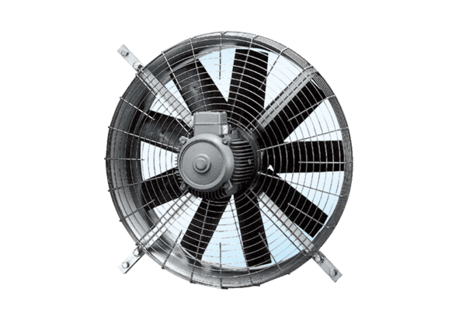Axial wall fan DZQ 71/4Packing unit: 1 pieceRange: C
Article number: 0083.0643Manufacturer: MAICO

