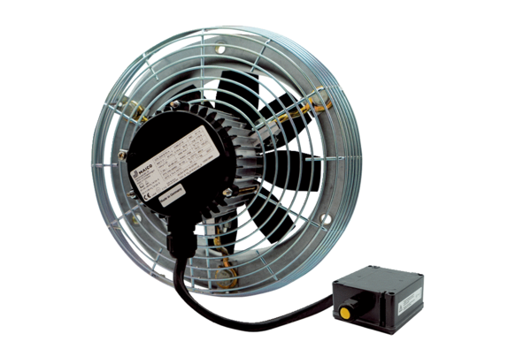Axial wall fan DZS 25/2 B Ex ePacking unit: 1 pieceRange: C
Article number: 0094.0119Manufacturer: MAICO

