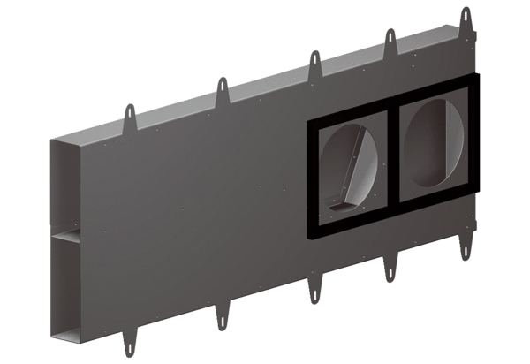Soffit element Duo LEPacking unit: 1 pieceRange: K
Article number: 0093.0087Manufacturer: MAICO

