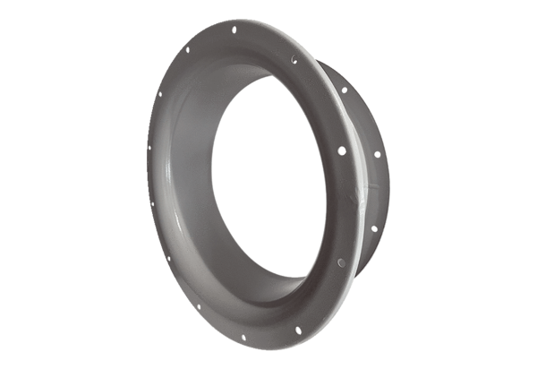Suction nozzle ADI 125Packing unit: 1 pieceRange: C
Article number: 0073.0240Manufacturer: MAICO

