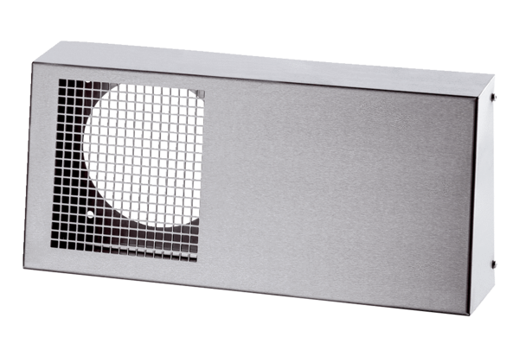Combi-wall connections Duo KWS EPacking unit: 1 pieceRange: K
Article number: 0093.1440Manufacturer: MAICO

