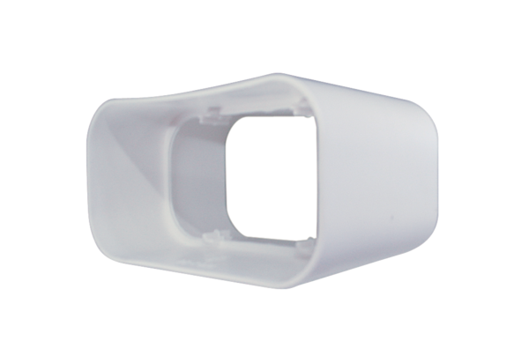Aeronom room air system FKV 125Packing unit: 1 pieceRange: K
Article number: 0078.0015Manufacturer: MAICO

