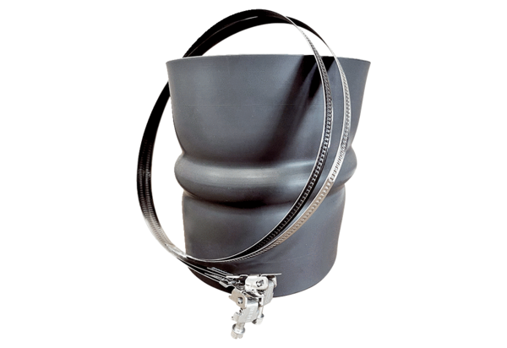Flexible cuff STKI 56Packing unit: 1 pieceRange: C
Article number: 0073.0496Manufacturer: MAICO

