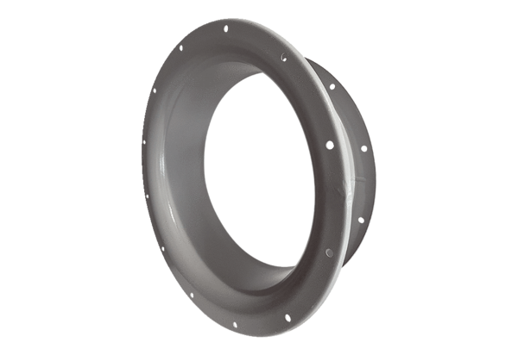Suction nozzle ADI 71Packing unit: 1 pieceRange: C
Article number: 0073.0235Manufacturer: MAICO

