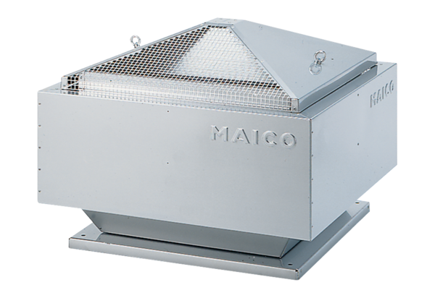Centrifugal roof fan DRD 25/64 BPacking unit: 1 pieceRange: C
Article number: 0087.0150Manufacturer: MAICO

