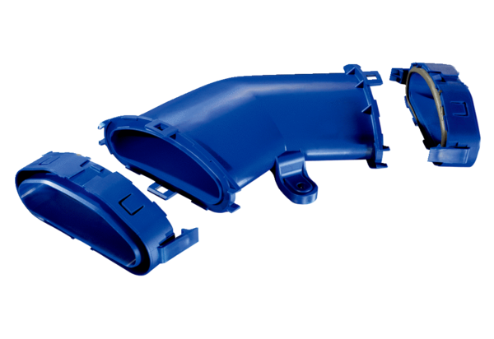Horizontal flat duct elbow FFS-BH45Packing unit: 1 pieceRange: K
Article number: 0055.0878Manufacturer: MAICO

