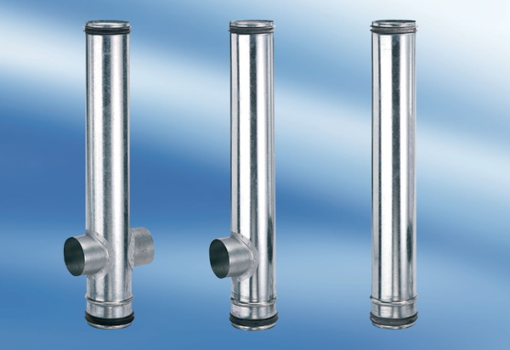BA 125/100-2Packing unit: 1 pieceRange: B
Article number: 0093.1010Manufacturer: MAICO

