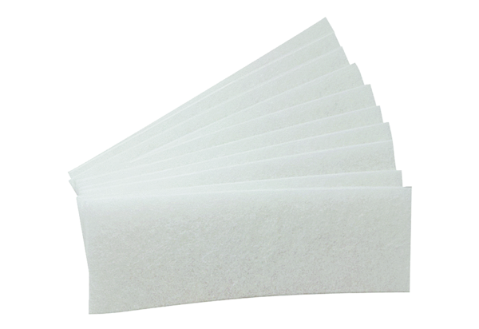Replacement filter mats WSG-EG 320/470Packing unit: 10 piecesRange: K
Article number: 0092.0562Manufacturer: MAICO

