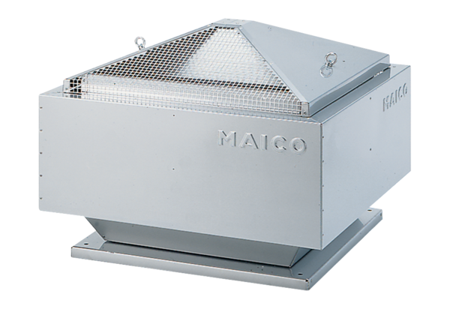Centrifugal roof fan DRD 25/6 BPacking unit: 1 pieceRange: C
Article number: 0087.0103Manufacturer: MAICO

