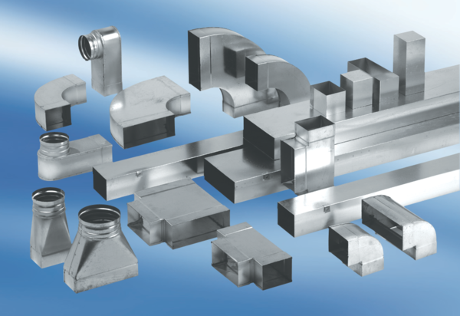90° channel elbows, long, vertical KB90LV/80/150Packing unit: 1 pieceRange: K
Article number: 0055.0580Manufacturer: MAICO

