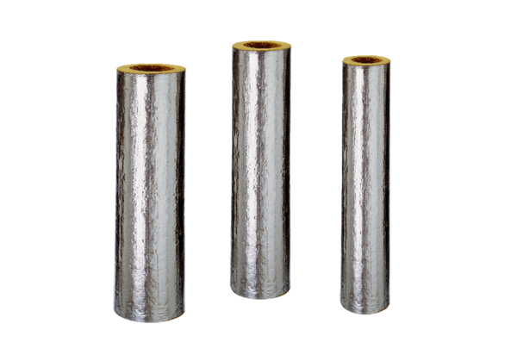BI 140Range: B
Article number: 0092.0400Manufacturer: MAICO

