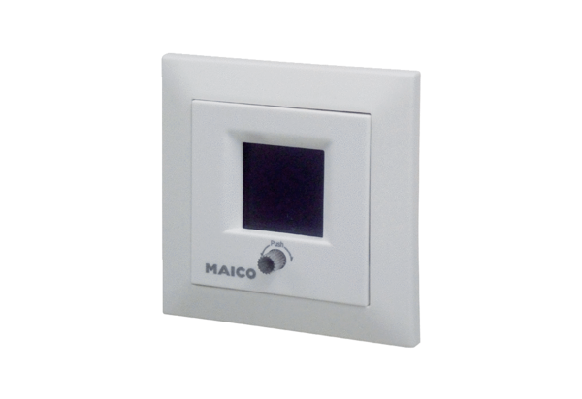Room air control RLS 5 UPPacking unit: 1 pieceRange: K
Article number: 0157.0846Manufacturer: MAICO

